SLCM_Part1_Report
By: Niko Madden and AJ Rallo
Abstract
We explored 639 Jira tickets and 993 household-member records from St. Luke Community Ministry’s 0-5 program. Only 426 of the tickets are real intakes; the other 213 are follow-up care-path tickets with no case data, so that makes the total number of families 426. Of those intakes, 122 (28.6%) show eviction risk, and the rate varies a lot by ZIP code. The most striking pattern is that a job does not protect a family from hardship: employed households earn a median of $2,000 a month versus $0 for unemployed ones, yet they face eviction at a slightly higher rate of 33% to 25%. A typical household has three people and two young children. Only 27 people appear on more than one intake. We can't tell what happens to families after intake because the data records no program stages or outcomes.
Question 1: Housing crisis severity
122 of 426 intake tickets (28.6%) show active eviction risk; the remaining 304 are considered stable. Excluding the 12 tickets marked Duplicate barely changes this (119 of 414, 28.7%). By eviction status, 59.9% are not being evicted, 24.9% are currently being evicted, 14.8% are unknown, and 0.5% have a 7-day notice. On housing, 234 tickets (54.9%) are renters with rent past due, 126 are renters with nothing past due, and 15 are unhoused.
Risk differs by ZIP code. The highest shares are 40212 (8 of 15, 53%), 40203 (8 of 17, 47%) and 40210 (7 of 16, 44%); the lowest are 40208 (3 of 27, 11%) and 40215 (14 of 89, 16%). Risk does not differ reliably by household size; instead, it ranges from 25% for 1-2-person households to 39% for 5-person households, with no clear trend. The one slight issue is that 63 tickets have no status whatsoever, so the data is not 100% accurate but pretty close.
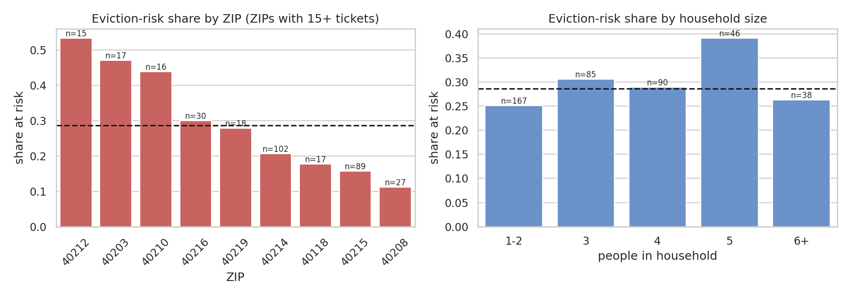
Figure 1. Eviction-risk share by ZIP code (left) and household size (right). Dashed line is the overall 28.6%.

Question 2: Employment versus income
Employed households do earn more (not a surprise): the median monthly income is $2,000 for the 175 employed households and $0 for the 222 unemployed ones (54% of unemployed households report $0 versus 5% of employed ones). What employment does not do is predict hardship. Eviction risk is 33% among employed households and 25% among unemployed ones, so having a job does not lower the risk (small difference again 33% to 25%). Rent past due is 60% versus 51%. Risk also does not fall as income rises: 27% at $0, 24% at $1-1,000, 29% at $1,001-2,000, and 36% above $2,000.
Income sources explain part of the gap. Among employed households, 43% list full-time work and 20% part-time work as their main source, but 31% rely mainly on food or cash benefits (SNAP/TANF). Among unemployed households, 50% rely on those benefits, 32% report no income, and 8% receive SSI/SSDI. In other words, having a job is not the same as having enough income, if anything having a job seems to be taking away needed benefits. The data cannot tell us exactly why; low wages, unstable hours, or high rents are all plausible explanations. But with our data we cannot be certain.
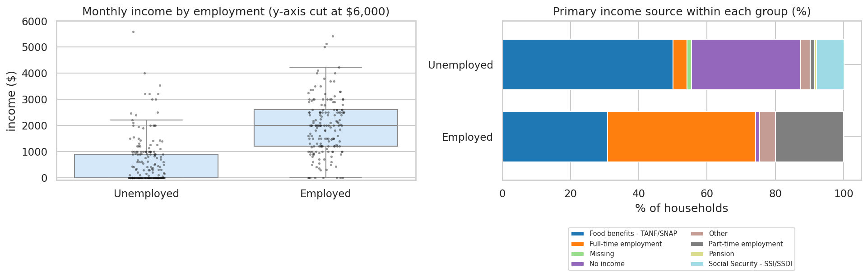
Figure 2. Monthly income by employment group (left, axis cut at $6,000) and primary source of income within each group (right).
Question 3: Household composition
The typical household has three people (median 3, mean 3.3), counting the primary contact plus additional members. One third are two-person households, 20% have three people, 21% have four, and about 20% have five or more; only 6% are single-person. The intake fields show a median of two children 17 and under (30% have exactly two; 24% one; 23% three; 16% four or more) and usually one adult (59%). The primary contact’s median age is 30 (middle half 26 to 35).
The long file describes the 993 additional members in 400 households. Of the 891 with a valid age, the median age is 6; half (49.6%) are under 6, 36.0% are 6-17 and 14.4% are adults. In 84% of households with known ages (304 of 360), at least one additional member is under 6, which fits SLCM’s focus on 0-5. Where the relationship is recorded, members are overwhelmingly sons (314) and daughters (248); 361 members have no relationship recorded.
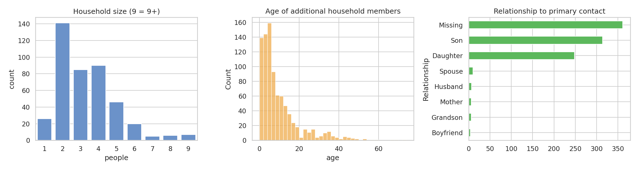
Figure 3. Household size (left), age of additional members (middle) and relationship to primary contact (right).
Question 4: Repeat contact
Repeat contact is uncommon at intake. The 426 intake tickets belong to 395 distinct people; 27 people (6.8%) appear on more than one (24 twice, 2 three times, and 1 four times). If all 639 tickets are counted, 150 of 439 PIDs appear more than once, but most of those are people who simply have follow-up care-path sub-tickets. The median gap between a person’s first and latest intake is 56 days (range 0 to 181).
Between the first and latest ticket, very little changes. Of the 27 repeat people, 18 were stable both times, 4 were at risk both times, 3 moved from stable to at risk, and 2 moved from at risk to stable, so eviction-risk status changed for 5 of 27. The raw housing-status text changed for 5 (18.5%) and the eviction-status text for 8 (29.6%); the most common change was Unknown to Not being evicted (3 people), which is likely just a miss for their first ticket.
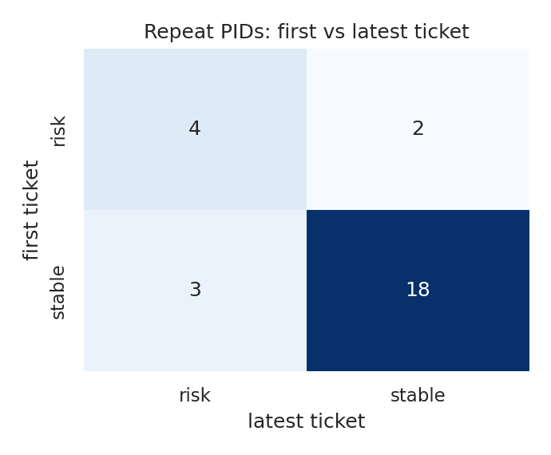
Figure 4. Eviction-risk status at first versus latest intake for the 27 repeat people.
A couple of issues, though as 27 people is too few to conclude a direction; one of them has two intakes on the same day (likely double entry). PID is name-based, but all 426 intake tickets are matched on name plus date of birth, so the weaker name-only matches (212 tickets) sit in the sub-tickets and do not affect this question. Families who returned without a new intake are invisible here.
Question 5: Data quality
We found 10 total issues of which are listed below. We picked two of them to go into further detail on the issue.
Inconsistent text entry (State). The State field has 12 different spellings of one state (KY, Ky, ky, Kentucky, KENTUCKY, some with stray spaces), affecting 226 rows. Cause: free-text entry with no dropdown. Handling: trim, uppercase, and map Kentucky to KY, because otherwise any group-by on state would treat one state as twelve. We also recommend SLCM use a dropdown (would just completely get rid of this).
Impossible values (ages). Four caregivers are ages below 15 (including -1 and 0), and nine household-member ages fall outside 0-100 (from -35 to 1824). We set these to missing but kept the rows, since the same tickets have valid housing and income data and deleting them would change our data. Members with missing age (93 more) were left missing rather than guessed.
Issue | Where | Evidence | Handling
Inconsistent text entry | Custom field (State) | 12 spellings of one state (KY, Ky, Kentucky, ...) | Standardized to KY (cleaning step 2)
Impossible values | Age at Intake; household Age | caregiver ages < 15: 4; member ages outside 0-100: 9 (min -35, max 1824) | Set to missing, kept the row
Extreme outliers | Monthly Rent; Past Due Rent; Income | rent > $5,000: 1; past due > $50,000: 1; income > $10,000: 6 | Rent/past-due set to missing; income flagged, medians used
Unreliable person key | PID | 212 of 639 tickets matched on name only (all but 1 are sub-tickets; all 426 intakes are Name + DOB) | Kept PID; used intake tickets only for repeat contact
Mixed grains in one file | Issue Type / Parent | 213 sub-tickets have no intake fields | Analysis restricted to the 426 intake tickets
Undeclared status / duplicates | Status | 12 intake tickets marked Duplicate | Flagged, kept, sensitivity in Q1
Unknown in a key field | Eviction Status | 63 intakes are Unknown (14.8%) | Counted as not at risk, with a caveat
Top-coded counts stored as text | People in Household | 15 + 6 rows say 'More than 5' | "More than 5" -> 6, flagged
Household counts disagree | Additional Members vs People in Household 17 and Under / 18+ | adults + children equals additional members + 1 for only 56.1% of intakes | Used additional members + 1 for household size (agrees 100% with the long file); children counts reported separately
Identifying free text | Landlord Name; Employer; Comments; Parent summary | Free-text columns that can contain personal names | Dropped and never displayed

What Did You Get to Know?
What surprised us most is how much of the export is not families at all. A third of the rows are follow-up tickets with no case data, so a file that looks like 639 families is really 426 intakes. We also expected employment to separate stable families from struggling ones, and that data does not do that whatsoever. Employed households earn far more at the median, as expected, yet their eviction-risk rate is no lower than that of unemployed households, and nearly a third of them rely mainly on SNAP or cash benefits.
We now believe SLCM’s population is mostly young renter families in acute rent trouble: about 55% of intakes are renters behind on rent, roughly 29% face eviction or homelessness, and a typical household has three people with two young children (sounds like a young family trying to get their feet under them). A few ZIP codes took a much harder hit than the rest, although each has fewer than 20 tickets (lack of data?). We also came to believe that repeat intake is rarer than SLCM’s "chronic" label suggests, since only 27 people came back through a new intake, though families may be getting repeat help through care-path tickets instead. One question we cannot answer with this data alone is what happens to families after intake: do those who receive longer-term support return to crisis less often than those who do not?

